# Activity 8 Methodical Problem Solving

COMM 2700

Your name: Jamie Lu, W0441213

## Exercise 1:

What are all of the steps you need to follow to complete a technical assignment?

1. Attend lectures
2. Know when it is due
3. Identify what specific things need to be done/what the goals of the assignment are
4. Set aside time to do the assignment, preferably with enough allowance incase you missed anything and remember it later on
5. Go through the assignment and link the lecture content to the assignment requirements
6. Get the necessary tools or software you need to do the assignment
7. Review lecture materials. Do research on areas that have gaps or areas wherein you need more information
8. Study the rubric of the assignment. If possible, create a brief checklist with all the things the rubric contains
9. Create a work schedule. Determine what needs to be done and when.
10. Work on the assignment. If it is something big, do it portion by portion, depending on the work schedule that was created.
11. After the assignment is finished, go through it at least 3 times to make sure you didn’t miss anything.
12. Submit the assignment.

## Exercise 2:

Using NSCC outlook, book in your calendar all of the steps you identified in exercise 1 need to do to complete a real technical assignment that you have due in the future. Show screen shots.

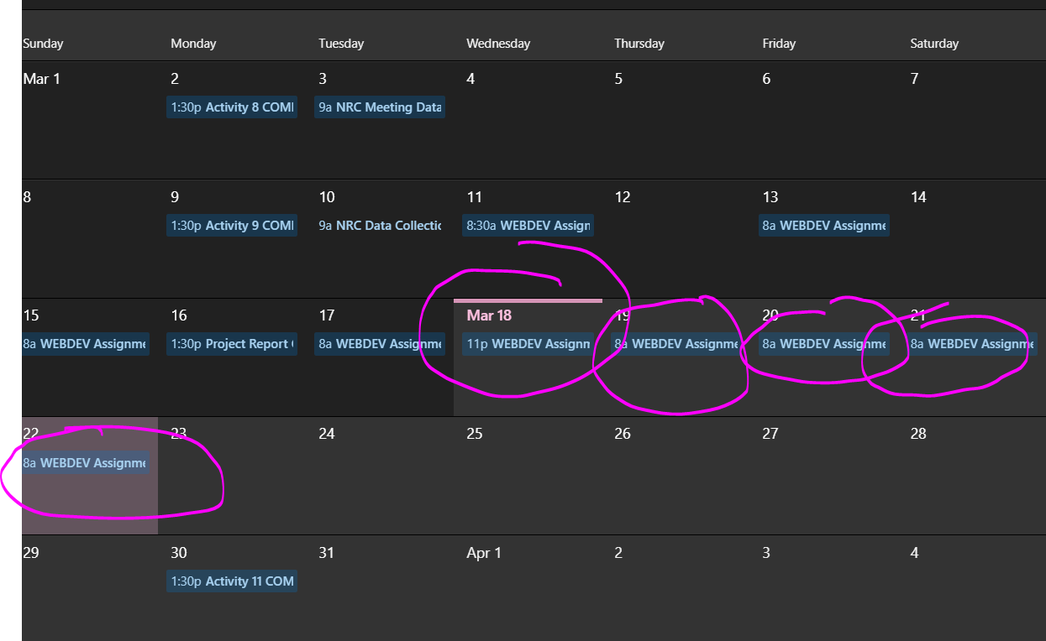

PHOTO OF NSCC OUTLOOK CALENDAR, ENCIRCLED ONES ARE FOR THE ASSIGNMENT

TASK SCHEDULE TABLE

|  |  |
| --- | --- |
| DATE | TASK |
| MARCH 11, 2020  Assignment is unlocked by teacher |  |
| MARCH 13, 2020  Skills needed:  CSS, HTML  Tools/Software needed:  Visual Studio Code, Internet, W3 Schools website, HTML and CSS3 Textbook, Internet Browser, Laptop |  |
| MARCH 15, 2020  1) Check the assignment instructions  2) Check the assignment rubrics  3) Grab the key points from the rubrics  4) Determine the website design  5) Read the book  6) Start coding  7) Look through W3 Schools website for tips  8) Triple check everything, make sure all the necessary points from instructions and rubric are met |  |
| MARCH 17, 2020  RUBRIC KEY POINTS:  1) Background images  2) Border (including curved border)  3) Box Shadow  4) Text Shadow  5) Background with linear gradient and radial gradient  6) Transform Property  7) Filter Property  8) All files in Brighspace and linked properly  9) Show effort and understanding of page layout  10) Clear and consistent code with appropriate comments |  |
| MARCH 18, 2020  This is the work schedule, in NSCC Outlook so that I receive reminders |  |
| MARCH 19, 2020 |  |
| MARCH 20, 2020 |  |
| MARCH 21, 2020 |  |
| MARCH 22, 2020 |  |

## Exercise 3:

Outline the steps for iteration.

1. Know when it’s due
2. Identify what specific skills and tools are needed
3. Acquire the skills and tools
4. Read instructions, know the rubric
5. Breakdown and schedule the work
6. Work iteratively
7. Revise time estimates

## Exercise 4:

List all the key programming functions (also known as Suggested Steps) from PROG 1700.

* Equals
* ToString
* Getters
* Setters
* Println
* Printf
* Print
* nextLine (with scanner function)
* nextInt (with scanner function)
* random

## Exercise 5:

Your company is building an app. Your job is to make a login screen. The login screen has to be fully functional and comparable to the login screens you might find for popular social media. List out all of the suggested steps/functions.

* Do research on different login screens
* Take inspiration from research and determine which aspects make it the most functional
* Design a layout of the login screen
* Create a user interface page (start with a blank one)
* Inside the panel, create the login form
* Create the login POST
* Create the page’s form